Call for paper

to participate in the following event in fall 2021:
Faculty of Business and Economics’s
Scientific Student’s Association’s Conference

The University of Pannonia’s Faculty of Business and Economics, along with its institutions, departments, as well as its teaching locations, with the support of the Scientific Student’s Council of the University of Pannonia and the University of Pannonia Faculty of Business and Economics’ Scientific Student’s Council announces the Institutional Scientific Student’s Association’s Conference at the University of Pannonia.

Students enrolled at BSc/BA, MSc/MA programmes can be qualified to participate.
The application has to be done via online registration with a short summary of the research paper handed in on the following website: http://etdk.uni-pannon.hu.

Important dates/deadlines:
- the date of the 2021 Institutional Scientific Student’s Association’s conference: 24th November 2021
- the deadline for registration and submission of the short summary: 3rd November 2021, 8:00 PM
- submission deadline for the final paper online: 15th November 2021, 11:00 AM
Formal requirements and other information can be found on the websites of the different faculties (login first to Moodle): https://moodle.gtk.uni-pannon.hu/course/view.php?id=5720

Annamária Sasné Grósz PhD Andrea Bencsik PhD
President of the Scientific Student’s Association at President of the Scientific Students’ Associations
the University of Pannonia at the Faculty of Business and Economics,
University of Pannonia

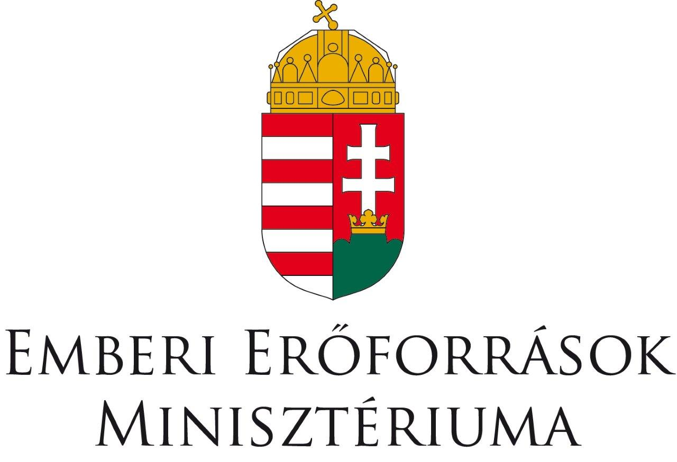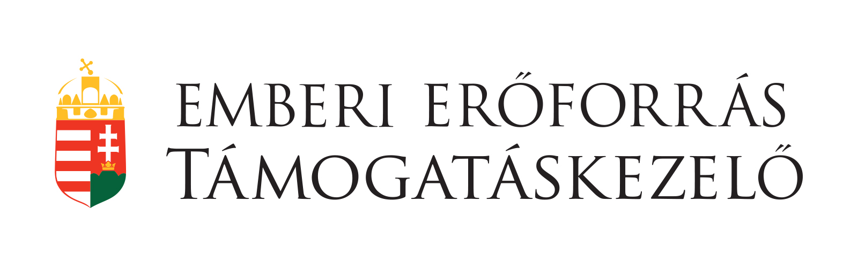
A program a Pannon Egyetem Gazdaságtudományi Kara által elnyert az Emberi Erőforrás Támogatáskezelő által támogatott „A hazai Tudományos Diákköri műhelyek és rendezvényeik” című projekthez (NTP-HHTDK-20-0026) kapcsolódóan valósul meg.

